Randyll Bearer: RLB97: CS1550: Project 3: VMSIM

**Recorded Statistics:**

**OPT()**: Not Completed

**RAND()**:

|  |  |  |  |  |
| --- | --- | --- | --- | --- |
| Frames | 8 | 16 | 32 | 64 |
| BZIP-FAULTS | 44209 | 4463 | 2583 | 1575 |
| BZIP-WRITES | 16488 | 1478 | 873 | 539 |
| GCC-FAULTS | 217060 | 150613 | 106286 | 75031 |
| GCC-WRITES | 37370 | 24832 | 17213 | 12130 |

**CLOCK():**

|  |  |  |  |  |
| --- | --- | --- | --- | --- |
| Frames | 8 | 16 | 32 | 64 |
| BZIP-FAULTS | 34926 | 3418 | 2120 | 1301 |
| BZIP-WRITES | 12155 | 1094 | 700 | 423 |
| GCC-FAULTS | 168291 | 115520 | 83860 | 57953 |
| GCC-WRITES | 22848 | 14349 | 11522 | 8685 |

**NRU() 100 Refresh Rate:**

|  |  |  |  |  |
| --- | --- | --- | --- | --- |
| Frames | 8 | 16 | 32 | 64 |
| BZIP - FAULTS | 34223 | 6274 | 5122 | 3113 |
| BZIP - WRITES | 9549 | 1252 | 1346 | 513 |
| GCC - FAULTS | 235415 | 132982 | 95720 | 92655 |
| GCC - WRITES | 17651 | 13611 | 9170 | 8444 |

**NRU() 200 Refresh Rate:**

|  |  |  |  |  |
| --- | --- | --- | --- | --- |
| Frames | 8 | 16 | 32 | 64 |
| BZIP - FAULTS | 44286 | 3967 | 3145 | 2573 |
| BZIP - WRITES | 8371 | 969 | 686 | 433 |
| GCC - FAULTS | 271318 | 174691 | 90702 | 74199 |
| GCC - WRITES | 16811 | 13819 | 10520 | 6928 |

**NRU() 300 Refresh Rate:**

|  |  |  |  |  |
| --- | --- | --- | --- | --- |
| Frames | 8 | 16 | 32 | 64 |
| BZIP - FAULTS | 46273 | 4608 | 2826 | 2400 |
| BZIP - WRITES | 6401 | 1112 | 636 | 459 |
| GCC - FAULTS | 292709 | 201555 | 103667 | 66114 |
| GCC - WRITES | 17008 | 13523 | 11225 | 6253 |

**NRU REFRESH RATE RESULTS**

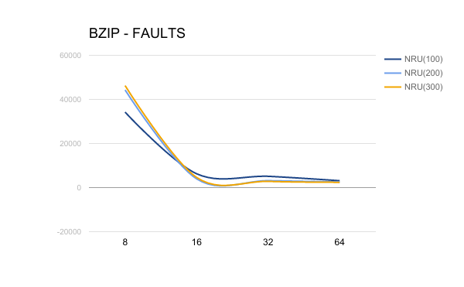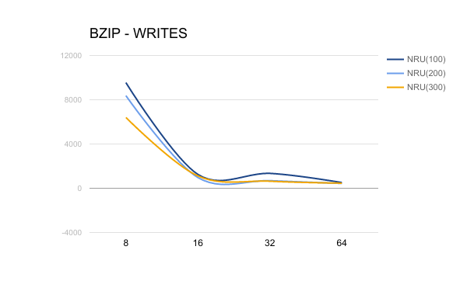

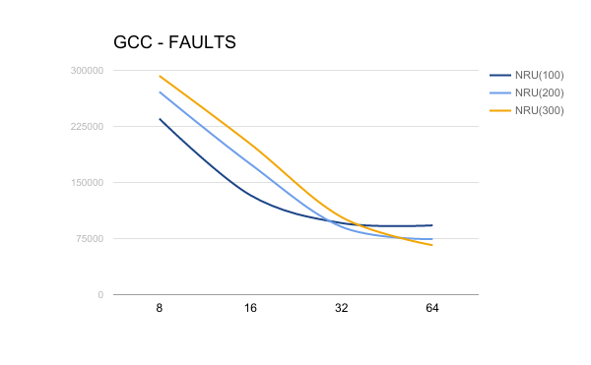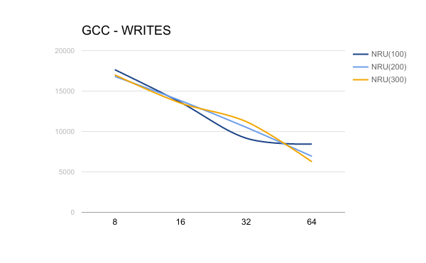

**NRU CONCLUSION:**

- Naturally which refresh rate I used in my OS would depend on the amount of frames I would expect to have, but I think 200 strikes a good balance out of the data I have collected. Going forward in the graphs, the NRU with refresh rate 200 will be used to represent the NRU Page Replacement Algorithm.

**BZIP: ALL ALGORITHMS**

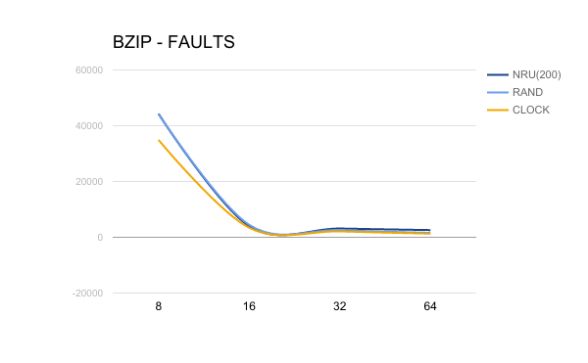

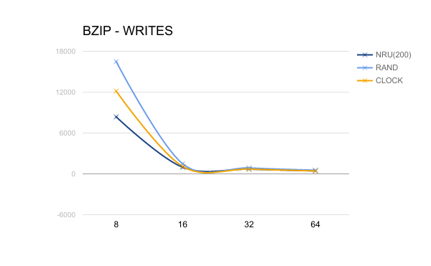

**GCC: ALL ALGORITHMS**

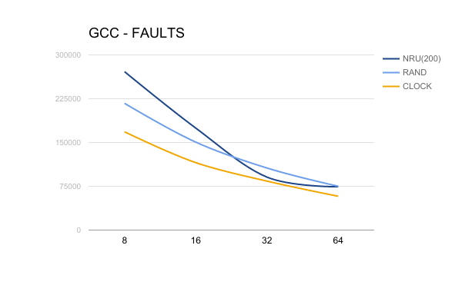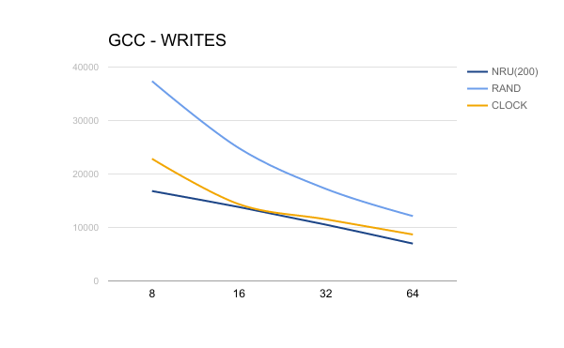

**CONCLUSION ON PAGE REPLACEMENT ALGORITHMS:**

- I think the results show that the Clock algorithm would be the most apt for use in an OS. Plus, it requires a bit less overhead than the nearest competitor NRU. RAND always has the chance of literally being OPT, but on average it’s just not going to be worth it so Clock it is.